DSA Assignment-04

Name: Palak Parhawk

Roll No.: 21052087



Ans:



Ans:

#include <stdio.h>

#include <stdlib.h>

/* A structure of linked list node */

struct node {

int data;

struct node *next;

} *head;

void initialize(){

head = NULL;

}

/*

Given a Inserts a node in front of a singly linked list.

*/

void insert(int num) {

/* Create a new Linked List node */

struct node* newNode = (struct node*) malloc(sizeof(struct node));

newNode->data = num;

/* Next pointer of new node will point to head node of linked list */

newNode->next = head;

/* make new node as new head of linked list */

head = newNode;

printf("Inserted Element : %d\n", num);

}

/*

Prints Linked List in reverse order without reversing it.

*/

void reverseLLPrint(struct node *head) {

if (head != NULL) {

reverseLLPrint(head->next);

printf("%d ", head->data);

}

}

/*

Prints a linked list from head node till tail node

*/

void printLinkedList(struct node *nodePtr) {

while (nodePtr != NULL) {

printf("%d", nodePtr->data);

nodePtr = nodePtr->next;

if(nodePtr != NULL)

printf("-->");

else

printf("-->NULL");

}

}

int main() {

initialize();

/* Creating a linked List*/

insert(8);

insert(3);

insert(2);

insert(7);

insert(9);

printf("\nLinked List\n");

printLinkedList(head);

printf("\nPrinting Linked List in Reversed Order\n");

reverseLLPrint(head);

return 0;

}

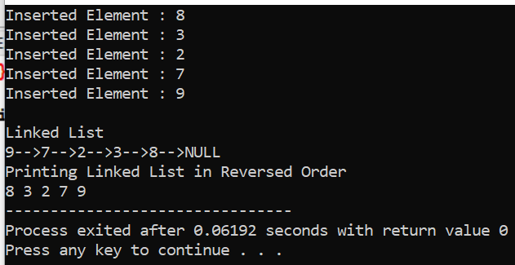

1. WAP to print mth node from the last of a linked list of n nodes.

Ans:

#include<stdio.h>

#include<stdlib.h>

//structure of a node

struct node{

int data;

struct node *next;

}*head,*temp;

int count=0;

//function for inserting nodes into a list

void insert(int val){

struct node* newnode = (struct node*)malloc(sizeof(struct node));

newnode->data = val;

newnode->next = NULL;

if(head == NULL){

head = newnode;

temp = head;

count++;

} else {

temp->next=newnode;

temp=temp->next;

count++;

}

}

//function for displaying a list

void display(){

if(head==NULL)

printf("no node ");

else {

temp=head;

while(temp!=NULL) {

printf("%d ",temp->data);

temp=temp->next;

}

}

}

//function for finding 3rd node from the last of a linked list

void last(int n){

int i;

temp=head;

for(i=0;i<count-n;i++){

temp=temp->next;

}

printf("\n%drd node from the end of linked list is : %d" ,n,temp->data);

}

int main(){

//creating list

struct node* head = NULL;

int n=3;

//inserting elements into a list

insert(1);

insert(2);

insert(3);

insert(4);

insert(5);

insert(6);

//displaying the list

printf("\nlinked list is : ");

display();

//calling function for finding nth element in a list from last

last(n);

return 0;

}

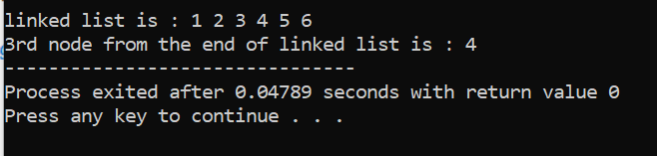

HA



Ans:



Ans:

// C program to count occurrences in a linked list

#include <stdio.h>

#include <stdlib.h>

/* Link list node */

struct Node {

int data;

struct Node* next;

};

/* Given a reference (pointer to pointer) to the head

of a list and an int, push a new node on the front

of the list. */

void push(struct Node** head_ref, int new_data)

{

/* allocate node */

struct Node* new_node = (struct Node*)malloc(sizeof(struct Node));

/* put in the data */

new_node->data = new_data;

/* link the old list off the new node */

new_node->next = (*head_ref);

/* move the head to point to the new node */

(*head_ref) = new_node;

}

/* Counts the no. of occurrences of a node

(search_for) in a linked list (head)*/

int count(struct Node* head, int search_for)

{

struct Node* current = head;

int count = 0;

while (current != NULL) {

if (current->data == search_for)

count++;

current = current->next;

}

return count;

}

/* Driver program to test count function*/

int main()

{

/* Start with the empty list */

struct Node* head = NULL;

/* Use push() to construct below list

1->2->1->3->1 */

push(&head, 1);

push(&head, 3);

push(&head, 1);

push(&head, 2);

push(&head, 1);

/* Check the count function */

printf("count of 1 is %d", count(head, 1));

return 0;

}

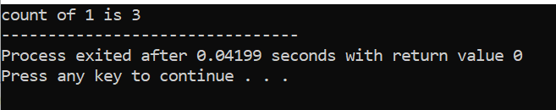



Ans:

/*

* C Program to Reverse only First N Elements of a Linked List

*/

#include <stdio.h>

#include <stdlib.h>

struct node

{

int num;

struct node *next;

};

void create(struct node **);

void reverse(struct node **, int);

void release(struct node **);

void display(struct node *);

int main()

{

struct node *p = NULL;

int n;

printf("Enter data into the list\n");

create(&p);

printf("Displaying the nodes in the list:\n");

display(p);

printf("Enter the number N to reverse first N node: ");

scanf("%d", &n);

printf("Reversing the list...\n");

if (n > 1)

{

reverse(&p, n - 2);

}

printf("Displaying the reversed list:\n");

display(p);

release(&p);

return 0;

}

void reverse(struct node **head, int n)

{

struct node *p, *q, *r, *rear;

p = q = r = *head;

if (n == 0)

{

q = q->next;

p->next = q->next;

q->next = p;

*head = q;

}

else

{

p = p->next->next;

q = q->next;

r->next = NULL;

rear = r;

q->next = r;

while (n > 0 && p != NULL)

{

r = q;

q = p;

p = p->next;

q->next = r;

n--;

}

*head = q;

rear->next = p;

}

}

void create(struct node **head)

{

int c, ch;

struct node *temp, *rear;

do

{

printf("Enter number: ");

scanf("%d", &c);

temp = (struct node *)malloc(sizeof(struct node));

temp->num = c;

temp->next = NULL;

if (*head == NULL)

{

*head = temp;

}

else

{

rear->next = temp;

}

rear = temp;

printf("Do you wish to continue [1/0]: ");

scanf("%d", &ch);

} while (ch != 0);

printf("\n");

}

void display(struct node *p)

{

while (p != NULL)

{

printf("%d\t", p->num);

p = p->next;

}

printf("\n");

}

void release(struct node **head)

{

struct node *temp = *head;

*head = (*head)->next;

while ((*head) != NULL)

{

free(temp);

temp = *head;

(*head) = (*head)->next;

}

}

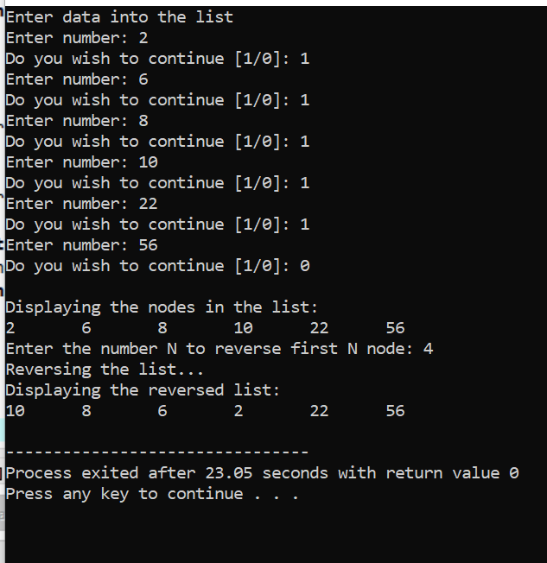



Ans:

/* C Program to remove duplicates in an unsorted

linked list */

#include<stdio.h>

#include<stdlib.h>

/* A linked list node */

typedef struct Node {

int data;

struct Node* next;

} Node;

// Utility function to create a new Node

Node* newNode(int data)

{

Node* temp = (Node*)malloc(sizeof(Node));

temp->data = data;

temp->next = NULL;

return temp;

}

/* Function to remove duplicates from a

unsorted linked list */

void removeDuplicates(Node* start)

{

Node *ptr1, *ptr2, *dup;

ptr1 = start;

/* Pick elements one by one */

while (ptr1 != NULL && ptr1->next != NULL) {

ptr2 = ptr1;

/* Compare the picked element with rest

of the elements */

while (ptr2->next != NULL) {

/* If duplicate then delete it */

if (ptr1->data == ptr2->next->data) {

/* sequence of steps is important here */

dup = ptr2->next;

ptr2->next = ptr2->next->next;

free(dup);

}

else /* This is tricky */

ptr2 = ptr2->next;

}

ptr1 = ptr1->next;

}

}

/* Function to print nodes in a given linked list */

void printList(struct Node* node)

{

while (node != NULL) {

printf("%d ", node->data);

node = node->next;

}

}

/* Driver program to test above function */

int main()

{

/* The constructed linked list is:

10->12->11->11->12->11->10*/

struct Node* start = newNode(10);

start->next = newNode(12);

start->next->next = newNode(11);

start->next->next->next = newNode(11);

start->next->next->next->next = newNode(12);

start->next->next->next->next->next = newNode(11);

start->next->next->next->next->next->next = newNode(10);

printf("Linked list before removing duplicates ");

printList(start);

removeDuplicates(start);

printf("\nLinked list after removing duplicates ");

printList(start);

return 0;

}

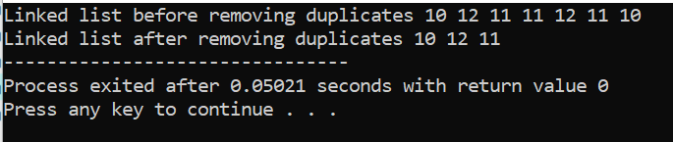



Ans:

/* Program to insert in a sorted list */

#include <stdio.h>

#include <stdlib.h>

/* Link list node */

struct Node {

int data;

struct Node* next;

};

/* function to insert a new_node

in a list. Note that this

function expects a pointer

to head_ref as this can modify the

head of the input linked

list (similar to push())*/

void sortedInsert(struct Node** head_ref,

struct Node* new_node)

{

struct Node* current;

/* Special case for the head end */

if (*head_ref == NULL

|| (*head_ref)->data

>= new_node->data) {

new_node->next = *head_ref;

*head_ref = new_node;

}

else {

/* Locate the node before

the point of insertion */

current = *head_ref;

while (current->next != NULL

&& current->next->data < new_node->data) {

current = current->next;

}

new_node->next = current->next;

current->next = new_node;

}

}

/* BELOW FUNCTIONS ARE JUST UTILITY TO TEST sortedInsert */

/* A utility function to create a new node */

struct Node* newNode(int new_data)

{

/* allocate node */

struct Node* new_node

= (struct Node*)malloc(

sizeof(struct Node));

/* put in the data */

new_node->data = new_data;

new_node->next = NULL;

return new_node;

}

/* Function to print linked list */

void printList(struct Node* head)

{

struct Node* temp = head;

while (temp != NULL) {

printf("%d ", temp->data);

temp = temp->next;

}

}

/* Driver program to test count function*/

int main()

{

/* Start with the empty list */

struct Node* head = NULL;

struct Node* new_node = newNode(5);

sortedInsert(&head, new_node);

new_node = newNode(10);

sortedInsert(&head, new_node);

new_node = newNode(7);

sortedInsert(&head, new_node);

new_node = newNode(3);

sortedInsert(&head, new_node);

new_node = newNode(1);

sortedInsert(&head, new_node);

new_node = newNode(9);

sortedInsert(&head, new_node);

printf("\n Created Linked List\n");

printList(head);

return 0;

}

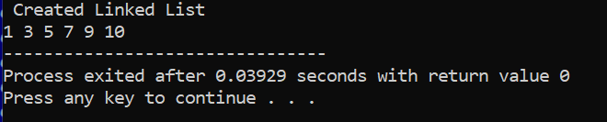



Ans:

/*

* C Program to Find Number of Occurences of All Elements in a Linked List

*/

#include <stdio.h>

#include <stdlib.h>

struct node

{

int num;

struct node *next;

};

struct node_occur

{

int num;

int times;

struct node_occur *next;

};

void create(struct node **);

void occur(struct node *, struct node_occur **);

void release(struct node **);

void release_2(struct node_occur **);

void display(struct node *);

void disp_occur(struct node_occur *);

int main()

{

struct node *p = NULL;

struct node_occur *head = NULL;

int n;

printf("Enter data into the list\n");

create(&p);

printf("Displaying the occurence of each node in the list:\n");

display(p);

occur(p, &head);

disp_occur(head);

release(&p);

release_2(&head);

return 0;

}

void occur(struct node *head, struct node_occur **result)

{

struct node *p;

struct node_occur *temp, *prev;

p = head;

while (p != NULL)

{

temp = *result;

while (temp != NULL && temp->num != p->num)

{

prev = temp;

temp = temp->next;

}

if (temp == NULL)

{

temp = (struct node_occur *)malloc(sizeof(struct node_occur));

temp->num = p->num;

temp->times = 1;

temp->next = NULL;

if (*result != NULL)

{

prev->next = temp;

}

else

{

*result = temp;

}

}

else

{

temp->times += 1;

}

p = p->next;

}

}

void create(struct node **head)

{

int c, ch;

struct node *temp, *rear;

do

{

printf("Enter number: ");

scanf("%d", &c);

temp = (struct node *)malloc(sizeof(struct node));

temp->num = c;

temp->next = NULL;

if (*head == NULL)

{

*head = temp;

}

else

{

rear->next = temp;

}

rear = temp;

printf("Do you wish to continue [1/0]: ");

scanf("%d", &ch);

} while (ch != 0);

printf("\n");

}

void display(struct node *p)

{

while (p != NULL)

{

printf("%d\t", p->num);

p = p->next;

}

printf("\n");

}

void disp_occur(struct node_occur *p)

{

printf("***************************\n Number\tOccurence\n***************************\n");

while (p != NULL)

{

printf(" %d\t\t%d\n", p->num, p->times);

p = p->next;

}

}

void release(struct node **head)

{

struct node *temp = *head;

*head = (*head)->next;

while ((*head) != NULL)

{

free(temp);

temp = *head;

(*head) = (*head)->next;

}

}

void release_2(struct node_occur **head)

{

struct node_occur *temp = *head;

*head = (*head)->next;

while ((*head) != NULL)

{

free(temp);

temp = *head;

(*head) = (*head)->next;

}

}

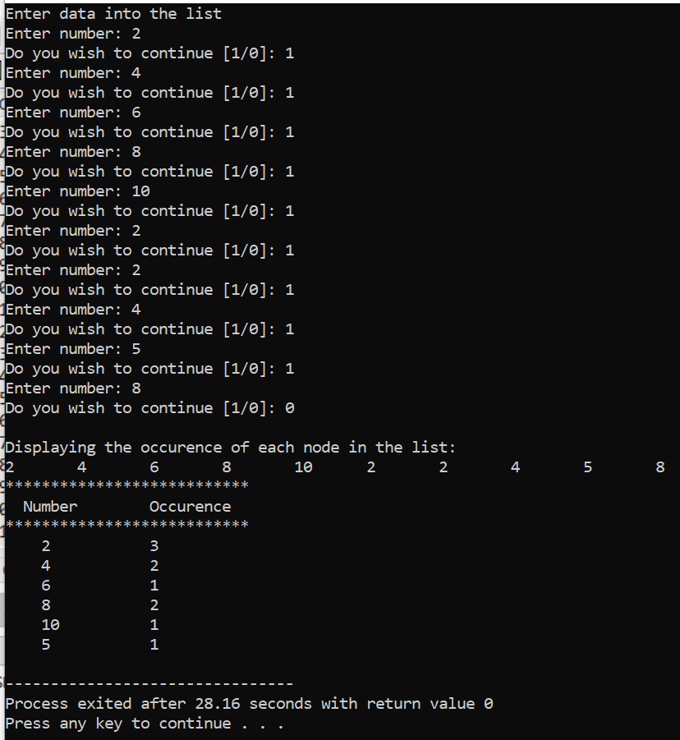



Ans:

/*

* C Program to Modify the Linked List such that All Even Numbers

* appear before all the Odd Numbers in the Modified Linked List

*/

#include <stdio.h>

#include <stdlib.h>

struct node

{

int num;

struct node *next;

};

void create(struct node **);

void generate_evenodd(struct node *, struct node**);

void release(struct node **);

void display(struct node *);

int main()

{

struct node *p = NULL, *q = NULL;

int key, result;

printf("Enter data into the list\n");

create(&p);

printf("Displaying the nodes in the list:\n");

display(p);

generate_evenodd(p, &q);

printf("Displaying the list with even and then odd:\n");

display(q);

release(&p);

return 0;

}

void generate_evenodd(struct node *list, struct node **head)

{

struct node *even = NULL, *odd = NULL, *temp;

struct node *reven, *rodd;

while (list != NULL)

{

temp = (struct node *)malloc(sizeof(struct node));

temp->num = list->num;

temp->next = NULL;

if (list->num % 2 == 0)

{

if (even == NULL)

{

even = temp;

}

else

{

reven->next = temp;

}

reven = temp;

}

else

{

if (odd == NULL)

{

odd = temp;

}

else

{

rodd->next = temp;

}

rodd = temp;

}

list = list->next;

}

reven->next = odd;

*head = even;

}

void create(struct node **head)

{

int c, ch;

struct node *temp, *rear;

do

{

printf("Enter number: ");

scanf("%d", &c);

temp = (struct node *)malloc(sizeof(struct node));

temp->num = c;

temp->next = NULL;

if (*head == NULL)

{

*head = temp;

}

else

{

rear->next = temp;

}

rear = temp;

printf("Do you wish to continue [1/0]: ");

scanf("%d", &ch);

} while (ch != 0);

printf("\n");

}

void display(struct node *p)

{

while (p != NULL)

{

printf("%d\t", p->num);

p = p->next;

}

printf("\n");

}

void release(struct node **head)

{

struct node *temp = *head;

*head = (*head)->next;

while ((*head) != NULL)

{

free(temp);

temp = *head;

(*head) = (*head)->next;

}

}

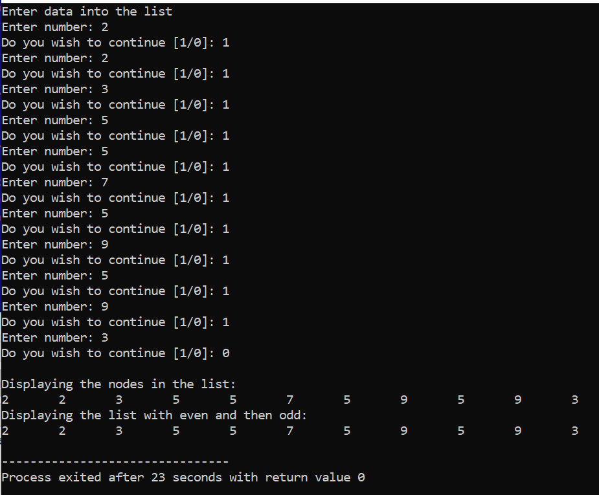



Ans:

/*

* C Program to Check whether a Singly Linked List is a Palindrome

*/

#include <stdio.h>

#include <stdlib.h>

struct node

{

int num;

struct node *next;

};

int create(struct node **);

int palin_check (struct node *, int);

void release(struct node **);

int main()

{

struct node *p = NULL;

int result, count;

printf("Enter data into the list\n");

count = create(&p);

result = palin_check(p, count);

if (result == 1)

{

printf("The linked list is a palindrome.\n");

}

else

{

printf("The linked list is not a palindrome.\n");

}

release (&p);

return 0;

}

int palin_check (struct node *p, int count)

{

int i = 0, j;

struct node *front, *rear;

while (i != count / 2)

{

front = rear = p;

for (j = 0; j < i; j++)

{

front = front->next;

}

for (j = 0; j < count - (i + 1); j++)

{

rear = rear->next;

}

if (front->num != rear->num)

{

return 0;

}

else

{

i++;

}

}

return 1;

}

int create (struct node **head)

{

int c, ch, count = 0;

struct node *temp;

do

{

printf("Enter number: ");

scanf("%d", &c);

count++;

temp = (struct node *)malloc(sizeof(struct node));

temp->num = c;

temp->next = *head;

*head = temp;

printf("Do you wish to continue [1/0]: ");

scanf("%d", &ch);

}while (ch != 0);

printf("\n");

return count;

}

void release (struct node **head)

{

struct node *temp = *head;

while ((*head) != NULL)

{

(*head) = (*head)->next;

free(temp);

temp = *head;

}

}

